**ENERGY CONSUMPTION TIME SERIES FORECASTING USING LSTM MODEL**

A Solution for Paperwork

Jay Patel

Smt. Kundanben Dinsha Patel Department of Information Technology, Chandubhai S Patel Institute Of Technology, Charotar University of Science and Technology

18*it*088@*charusat.edu.in*

***Abstract*—** The rapid increase in human population and development in technology have sharply raised [power consumption](https://www.sciencedirect.com/topics/engineering/electric-power-utilization) in today's world. Since electricity is consumed simultaneously as it is generated at the power plant, it is important to accurately predict the energy consumption in advance for stable power supply. Time series data are collected based on certain periods which have constants value (e.g. hourly, daily, weekly or monthly), it can be used to forecast or predict future circumstance. Prediction is one of the objectives of the time series analysis by identifying the model from previous data and assuming the current information will also occur in the future. The paper presents two approaches with one using a Recurrent Neural Network (RNN) and another one using a Long Short-Term Memory (LSTM) network, which only considers the previous electricity consumption to predict the future electricity consumption.

**INTRODUCTION**

Electricity consumption is a time-dependent attribute. Therefore, there are approaches that use time series to build the model to predict electricity consumption. Availability of past information leads to solutions based on time series analysis since it reflects the time-dependent variations. The forecasts for electricity consumption have been identified as short term (hourly to one week), mid-term, and long forecasts. Time-series analysis techniques are addressed using conventional approaches and AI-based approaches. Past research shows these techniques perform better for short term

forecasting but poor in mid-term and lon-term forecasting. The research conducted on mid-term to long term forecasting shows an excess of 40%-50% in relative errors. There are many challenges for mid-term and long-term electricity consumption forecasting, and thus form the focus of this paper.

This paper presents two approaches, a RNN and a LSTM, to forecast electricity consumption for short-term, mid-term and long-term. The RNN and the LSTM were used to predict daily, trimester and thirteen monthly electricity consumption. The RNN and the LSTM are compared with the most common and popular electricity consumption prediction models. Models have shown to minimize the Root Mean Square Error compared to the other models. The models were tested on the publicly available dataset. The experiments were conducted on predicting both an individual houses electricity consumption. The LSTM and RNN have achieved, on average a Mean Square Error (RMSE) for all cases.

**PROPOSED SYSTEM**

Prediction of electrical power consumption in residential and commercial buildings is very important to provide better energy management services. Due to the impact of unpredictability or the noisy arrangement of data, accurate electricity consumption prediction is a challenging task. For these reasons, the forecasting model sometimes generates incorrect prediction results. Moreover, several methods have been developed based on traditional networks with high error rates. The traditional methods have the problems of needing to learn from scratch, overfitting or short-term memory challenges if the data increase or the correlation between variables is complicated. These issues can be easily solved using sequential learning models, through modeling the spatial and temporal features for electricity consumption is also challenging. Therefore, in this paper, we developed a RNN with LSTM model and a data preprocessing step to efficiently predict electricity consumption in residential and commercial buildings.

**METHODOLOGY**

Deep learning is capable of learning from hidden patterns with no feature selection and outperform most of the machine learning and statistical methods to achieve various tasks. Time series data holds a sequential pattern, in which the data holds co-relationships between parallel data instances. Sequential data is handled by Recurrent Neural Networks (RNN), Long Short-Term Memory Networks (LSTM) and memory networks due to the capability of memory to hold past information.

**RNN (Recurrent neural network)**

The recurrent neural network (RNN) is another popular deep learning architecture, where connections between units form a directed graph along with the sequence information from the input, as depicted. The RNN processes a sequence of input data by using their internal state and turns into a vanishing gradient problem, which has a major negative effect on the model accuracy. An enhanced version of RNN is LSTM, which overcomes the vanishing gradient problem via the concept of gates (input, forget, and output) and memory cells.

**Time Series**

Time series Models and forecasting methods have been studied by various people and detailed analysis can be found in. Time Series Models can be divided into two kinds. Univariate Models where the observations are those of single variable recorded sequentially over equal spaced time intervals. The other kind is the Multivariate, where the observations are of multiple variables. A common assumption in many time series techniques is that the data are stationary. A stationary process has the property that the mean, variance and autocorrelation structure do not change over time. Stationarity can be defined in precise mathematical terms, but for our purpose we mean a flat looking series, without trend, constant variance over time, a constant autocorrelation structure over time and no periodic fluctuations. There are a number of approaches to modelling time series

**Dataset Description and Preparation**

The dataset was obtain from the Kaggle website, by processing time series energy consumption data, for example, the historical data of energy consumed by a building from 2004 to 2018, it is possible for a model to reveal trends and patterns, but also, to predict future energy consumption pattern. As seen in below figure, the data exhibits hourly, daily, yearly patterns,

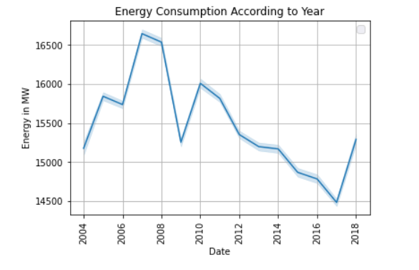

According to year

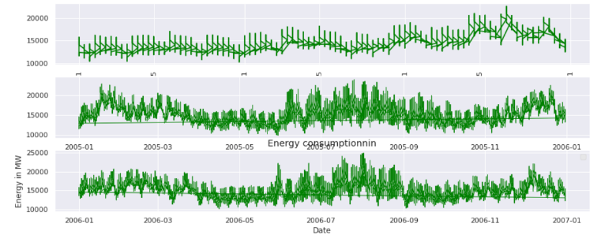

According to year (2004,2005,2006)

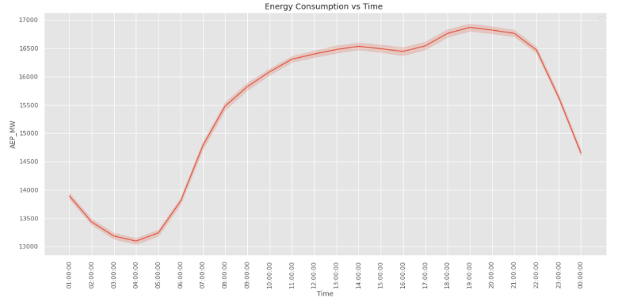

According to day

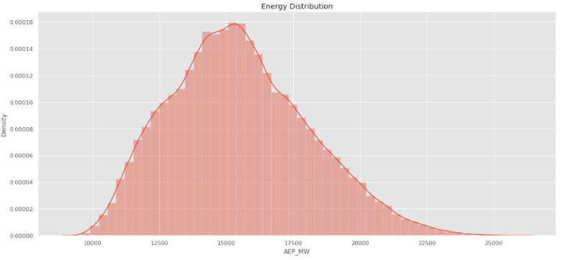

Energy distribution

**Prediction using LSTM**

Predictions of electricity consumption process LSTM model parameters are determined by experience of trial and error. set to find the best MSE. The horizontal axis is consumption electricity data and the vertical axis is sum of consumption electricity each data. The blue graphic is actual and the red one is predicted result. Actual data and prediction have quite different comparison.

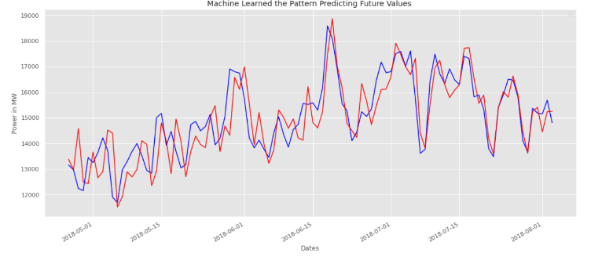

Comparison between actual and predicted consumption of electricity

**CONCLUSION**

The paper focuses on model which can be used to predict electricity consumption for an individual house for short term, mid-term and long term. The paper compares RNN and LSTM by conducting experiments for the publicly available dataset. RNN and LSTM have shown to perform similar to for short term predictions while outperformed all the other models in mid-term and long-term predictions. It is evident through the dataset that the RNN and LSTM is capable of predicting short term, mid-term and long-term forecasts for electricity consumption with high accuracy.

As future work i propose to explore and experiment with various techniques in the pre-processing phase, particularly in defining the best training data set for processing of LSTM in order to improve consistency and accuracy of results.

**REFERENCES**

1. Rahman, A., Srikumar, V., Smith, A.D.: Predicting electricity consumption for commercial and residential buildings using deep recurrent neural networks. Applied energy. 212, 372-385 (2018).

2. Wang, Y., Chen, Q., Hong, T., Kang, C.: Review of smart meter data analytics: Applications, methodologies, and challenges. IEEE Transactions on Smart Grid. (2018).

3. Deb, C., Zhang, F., Yang, J., Lee, S.E., Shah, K.W.: A review on time series forecasting techniques for building energy consumption. Renewable and Sustainable Energy Reviews. 74, 902-924 (2017).

4. Amber, K., Ahmad, R., Aslam, M., Kousar, A., Usman, M., Khan, M.: Intelligent techniques for forecasting electricity consumption of buildings. Energy. 157, 886-893 (2018).

5. Cai, H., Shen, S., Lin, Q., Li, X., Xiao, H.: Predicting the energy consumption of residential buildings for regional electricity supply-side and demand-side management. IEEE Access. (2019).